

# NATIONAL UNIVERSITY OF SCIENCES AND TECHNOLOGY

SCHOOL OF MECHANICAL AND MANUFACTURING ENGINEERING

MECHANICAL ENGINNERING (ME-15)

# PROGRAMMING:

Lab task 8:

**SUBMITTEED BY: MUHAMMAD ALI SHOUKAT**

**REGISTRATION NUMBER: 457397**

**Task 1:**

#include<bits/stdc++.h>

using namespace std;

int main(){

double avg,sum=0;

int size;

cout<<"enter the number of elements for array to find the average"<<endl;

cin>>size;

int arr[size];

cout<<"enter the desired elements in the array "<<endl;

for(int i=0;i<size;i++){

cin>>arr[i];

sum+=arr[i];

}

avg=double(sum/size);

cout<<"the average is "<<avg;

return 0;

}

**Output:**

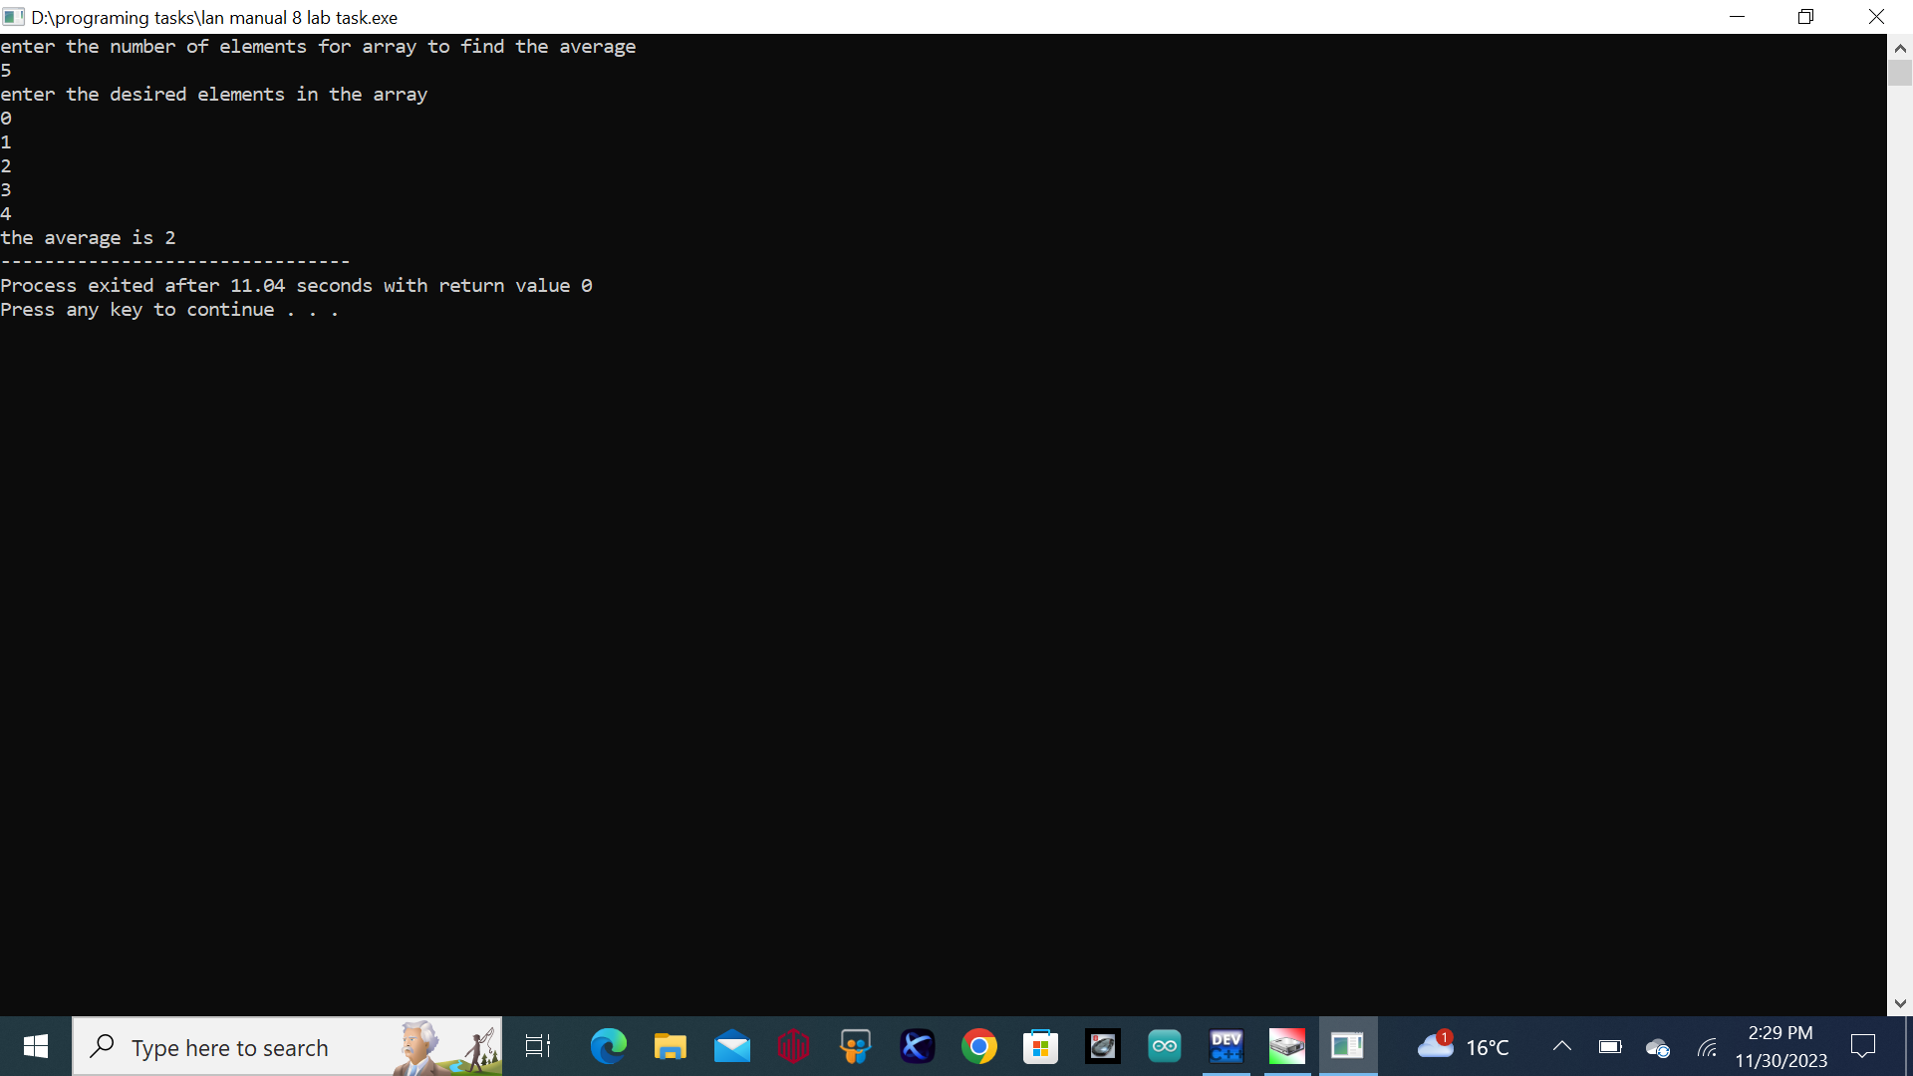

**Task 2:**

#include<bits/stdc++.h>

using namespace std;

int main(){

int size=5;

int arr[size],temp=0;

cout<<"enter the desired 5 elements in the array "<<endl;

for(int i=0;i<size;i++){

cin>>arr[i];

}

for(int j=0;j<size;j++){

for(int k=0;k<size-1;k++){

if(arr[k]>arr[k+1]){

temp=arr[k];

arr[k]=arr[k+1];

arr[k+1]=temp;

}

}

}

cout<<"the resulted bubble sorted array is ";

for(int m=0;m<size;m++){

cout<<arr[m]<<" ";

}

return 0;

}

**Output:**

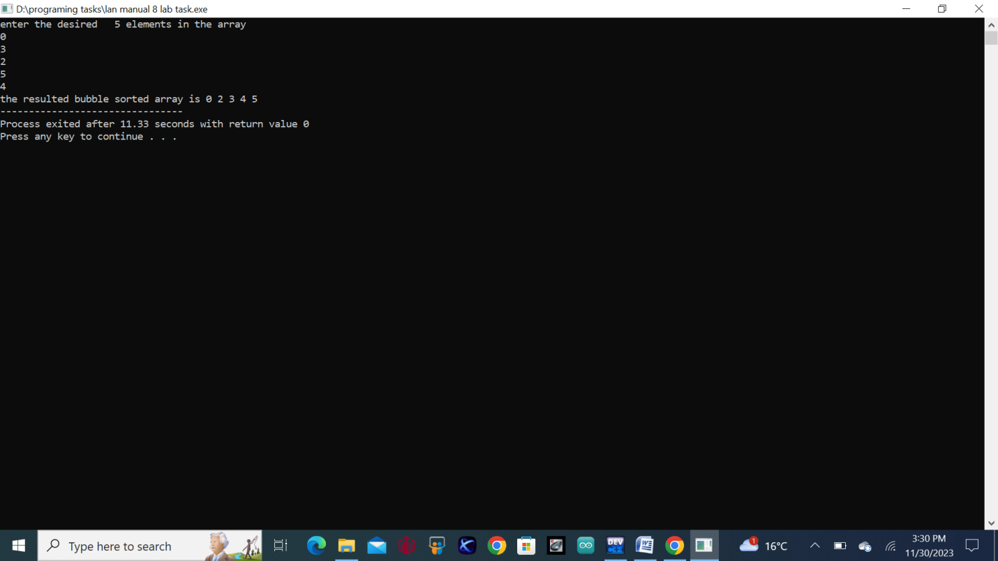

**Task 3:**

#include<bits/stdc++.h>

using namespace std;

int main(){

int size=5;

int arr[size];

cout<<"Enter the desired 5 integers"<<endl;

for (int i=0; i<size; i++) {

cin>>arr[i];

}

for (int i=0; i<size-1; i++) {

int num=i;

for(int j=i+1; j<size; j++) {

if(arr[j]<arr[num]) {

num=j;

}

}

int temp=arr[i];

arr[i]=arr[num];

arr[num]=temp;

}

cout<< " the resulted sorted array is ";

for(int i = 0; i < size; i++) {

cout<<arr[i]<<" ";

}

return 0;

}

**Output:**

